Carmen-Alyce Murray
PO Box 572
Piscataway, NJ 08855
(732) 648-6412 (M) (732) 791-5705 (H)

To Whom It May Concern:

As you will note from my attached resume, my education has provided me with extensive knowledge in communications, marketing and public relations. This education along with my work experience in exhibit management, event/conference planning and meeting logistics has made me more than ready for the challenge of an opening within your facility. These experiences developed within medical, non-profit and other corporate industries have enhanced my ability to establish a rapport with clientele and continually fine-tune my skills.

In past positions, I have acquired experience within meeting, exhibit, hospitality and conference venues. I have managed the execution of national and international congresses, CME initiatives, Advisory Board meetings, fundraising and other sponsorship/incentive events. These initiatives helped me to become a skilled professional in RFP development, client program and speaker (VIP) management, pursuit of sponsor opportunities, travel logistics, contract site search and negotiation, incentive packaging, staff and vendor supervision, new booth builds, budget analysis, tactical ROI measurements and post-program reporting.

In addition to my expertise in the above skills, I am also skilled in template and SOP development along with graphic design, e.g., formatting and processing presentations, charts / graphs, special announcements or invitations, packets, calendars, and newsletters.

I am interested in a position where I can utilize my skills in a fast paced business environment. If offered the opportunity, I believe this employment arrangement between us would be beneficial for both parties. I am recognized by peers and employers as a highly motivated, hard-working professional with a solid reputation for creating processes, improving procedures and producing measurable results. I am also known for my ability to motivate and develop teams by setting clear goals and serving as a mentor to others. I adapt easily to changing situations and to the demands of the business world and above all -- I am never afraid to learn more. I look forward to hearing from you.

Sincerely,

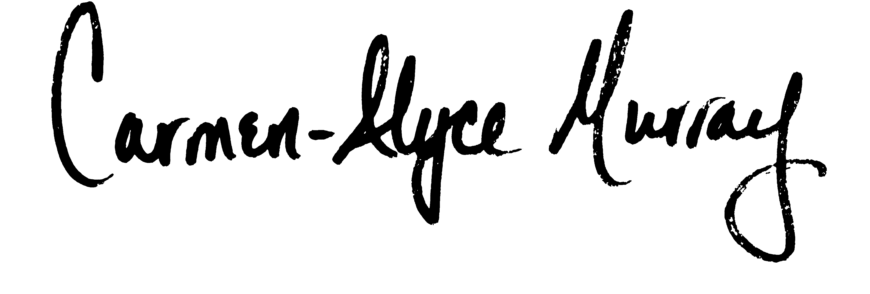
Carmen-Alyce Murray
Enclosure

Education: University of North Carolina - Chapel Hill, NC
1988-1992 Major: Communication Minor: African-American Studies

Experience:
July 2008 – Manager, Convention & Meeting Services
Aug 2010 Evolution Medical Communications – Pearl River, NY &
The Darwin Academy – Saddle Brook, NJ
(Initially employed with the company’s commercial branch to later transfer to its CME partner division.)

Most Successful Accomplishment
Program management and execution of a 34-city product theater project within a larger educational forum. Duties include speaker recruitment, daily speaker and forum communication, travel management, on-site support and post-show compliance reporting
- Manage logistic elements of promotional and educational events in the form of trade shows, Advisory Boards, CME events, webinars, and KOL meetings through site search and selection, RFP development, contract negotiation and execution, on-site support, vendor mgmt (AV, housing, ground, air), BEOs, and post reconciliation
- Proactively build and maintain budget, project plans and timelines for coordinated events
- Actively participate in strategic planning with clients and executive management team
- Successful execution of exhibition logistics (including theme, messaging, literature, direct mail and sponsorships)
- Standardized over 25 communication templates and tracking documents within the organization
- Collaborate efforts of creative teams and manage routing to vendors to produce all meeting materials
- Project management of client on-site briefing documents
- Project management with conference promoters for PR opportunity negotiation and implementation
- Participation in new business proposals, budgets and presentation development

February 2006 – Exhibitions Specialist
July 2008 GE Healthcare (Life Sciences Division) – Piscataway, NJ

Most Successful Accomplishment
Manager of largest conference and event schedule amongst 3 exhibition specialists
- Implement, manage and evaluate more than 60 national and international trade shows, meetings, webcasts, road shows and product launches for successful promotion
- Interface with marketing, campaign and program managers to identify and evaluate overall strategy at potential events
- Oversee and report budget expenditures along with post program ROI
- Serve as team member on company’s annual national sales meeting and sales incentive events

May 2004 – Freelance Marketing Communications Associate / Event, Trade Show & Meeting Planner
February 2006 Central NJ / NY

(Companies that can provide references are GE, Sarnoff, IEEE, medical educational companies and others)

Freelance employee with several companies to manage and execute highly visible commercial and educational events in the form of trade shows, Advisory Boards, KOL meetings, CME programs and incentive events

- Develop and manage exhibit logistics
- Coordinate and manage meeting logistics
- Research and negotiate relevant exhibition packages w/ sponsorship opportunities for companies
February 2002 – Convention Planner
February 2004 Aventis Pharmaceuticals – Bridgewater, NJ

Most Successful Accomplishment
Simultaneously managed the construction of (2) new exhibit properties (~$3 million in total) to include idea conception, RFP submission, contract negotiation, final layout and marketing in-booth tactics

Convention Planner - Aventis PHARMACEUTICALS (Cont’d)

- Manage booth activities and ancillary event logistics for company trade shows (~50/yr) to include theme development, site search, contract negotiation, housing/travel, BEOs and vendor mgmt in specific therapeutic areas (Endocrinology, Primary Care and Osteoporosis)
- Manage the marketing & convention services budget for selected therapeutic areas (~$8 million)
- Provide as needed support to meetings department with annual sales, company and incentive meetings
- Dotted-line supervision and mentoring to support coordinators
- Develop ROI implementation measurement and assessment tools
- Adhere to compliance branding, association and/or FDA guidelines

January 1998 – Trade Show & Event Coordinator (Contract Employee Jan ‘98 – July ‘98)
April 2001 Quintiles Transnational – RTP, NC

- Manage trade show, meetings, special events, sponsor, and webcast promotions (~55/yr)
- Plan/manage internal meetings, conferences and incentive logistics (~5/yr)
- Manage property inventory, refurbishment, and inventory manuals with designated exhibit house
- Assist in determining (ROI) through database creation, post-show reports and surveys
- Oversee and report exhibit budget expenditures along with post program ROI
- Provide design support in formal presentations, promotional pieces, display graphics, etc.
- Implement and maintain online internet ordering system of all printed materials

April 1997 – Assistant Director
December 1997 Sisterhood Agenda, Inc. – Durham, NC (Non-Profit Organization)
Most Successful Accomplishment
Lead PR event that generated over $15,000 in financial and in-kind support, PR, and membership
- Extensive special event, meeting planning and grant research/ writing
- Sponsorship and in-kind research and request of area businesses
- Trainer to staff needed to teach the organization’s mentor program initiatives to students
- Edit, design, and publish quarterly newsletter and other agency publications
- Supervise office operations of staff members, interns and volunteers
August 1995 – Executive Office Manager
April 1997 Corporation for Enterprise Development - Chapel Hill, NC (Non-Profit Organization)

Most Successful Accomplishment
Coordination of annual 3-day conference (Attendance=1,500)
- Coordinate special events (i.e., conferences, conventions, and meetings)
- Assist in design of agency publications such as newsletters, brochures, and flyers
- Coordinate and supervise office operations of staff, interns and volunteers
- Assist in grant research and writing procedures

August 1994 – Assistant Program Coordinator
August 1995 Alamance Coalition on Adolescent Pregnancy - Burlington, NC (Non-Profit Organization)
- Coordinate special events (i.e., conference, fundraisers, public relations/donor campaigns)
- Extensive grant research and writing
- Implement, recruit and train volunteers for various programs
- Design agency publications such as newsletters, brochures and flyers

Training:
- Exhibitor Show – Current CTSM Candidate on final level of completion
- Exhibitor Show Attendee – March 2010, 2009 2007, 2004, 2003, 2002, Las Vegas, NV
- HCEA (Healthcare Convention and Exhibitors Association) Annual Mtg – June 2009
- Foundations for Managing (Management by Strengths) – August 2003, Bridgewater

Memberships:
- Healthcare Convention & Exhibitors Association
- Trade Show Exhibitors Association
- MPI Membership
- UNC Alumni Association

References: Available Upon Request

